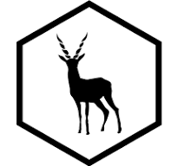

**BLACKBUCKS INTERNSHIP**

**PROJECT NAME: LANGUAGE TRANSLATOR USING CHATGPT**

**PROJECT REPORT**

Submitted in partial fulfilment of the requirements for the Internship

**Submitted by:**

Shaik Tasleem Kousar

22HU1A05D5

Department of Computer Science and Engineering

Chebrolu Engineering College

**Submitted to**: BlackBucks Organization

**Abstract**

Brief Introduction: The "Language Translator using ChatGPT" is a web-based application designed to translate text from one language to another in real time using OpenAI’s ChatGPT language model. This project leverages the advanced natural language understanding and generation capabilities of ChatGPT to ensure accurate, context-aware translations across multiple languages. Unlike traditional translation tools that rely on fixed rules and dictionaries, ChatGPT can understand the nuance, tone, and meaning behind text, making translations more natural and conversational. The system takes user input in the source language, sends it to the ChatGPT API, and returns a high-quality translation in the target language. This translator supports a wide range of languages and is particularly useful for education, travel, global communication, and localization of content. Technologies & Libraries Used :

♣ AI & Language Model

∙ OpenAI API (openai Python/JavaScript library) To access ChatGPT and perform language translations using prompts.

♣ Backend Technologies

∙ Python o Main backend programming language.

∙ Flask or FastAPI o To create REST APIs or handle server-side logic.

∙ openai (pip install openai) o For integrating ChatGPT API calls.

∙ dotenv (pip install python-dotenv) o To manage and secure API keys via environment variables.

♣ Frontend Technologies

∙ HTML/CSS/JavaScript o For building a user-friendly interface.

∙ Bootstrap or Tailwind CSS (optional) o To enhance UI design quickly.

∙ Fetch API / Axios o To make API calls from frontend to backend.

♣ Testing Tools (optional but good for quality)

∙ Postman o For testing API endpoints.

∙ unittest / pytest o For writing backend tests.

♣ Deployment Tools (if needed)

∙ Render / Vercel / Netlify o For frontend or full-stack deployment.

∙ Heroku / Railway / PythonAnywhere o For deploying Python Flask backend.

∙ Git & GitHub o For version control and code hosting.

♣ Security Tools

∙ dotenv / environment variables o To securely handle the OpenAI API key and configurations. Project Flow / Architecture Design 1. User Interface (Frontend)

∙ A clean and simple web page where the user: o Enters the text to be translated. o Selects the source language and target language from dropdowns. o Clicks a “Translate” button.

∙ The frontend sends this data to the backend using a POST request (via Fetch API or Axios). 2. Backend (Flask or FastAPI)

∙ Receives the user input (text + source & target languages).

∙ Formats a prompt for ChatGPT to instruct it to perform the translation

∙ Sends the prompt to OpenAI’s ChatGPT API.

∙ Receives the translation from the API response.

∙ Returns the translated text to the frontend in JSON format. 3. Response Handling (Frontend)

∙ The frontend receives the translated text.

∙ Displays the translated output in a textbox or result area.

∙ Optional: add copy, clear, or speak buttons for extra UX.

♣ Workflow Summary

1. User Input: Enter text + select languages.

2. API Request: Send input to Flask backend.

3. Prompt Build: Backend constructs a translation prompt.

4. OpenAI Call: Send prompt to ChatGPT via OpenAI API.

5. Receive Translation: Extract translated output.

6. Return Result: Send it back to frontend and display it. Conclusion / Expected Output The Language Translator using ChatGPT project demonstrates how powerful AI language models can be integrated into real-world applications to break language barriers and improve global communication. By utilizing OpenAI’s ChatGPT API, this application provides accurate and context-aware translations between a wide variety of languages. The system offers a user-friendly interface for entering text, selecting source and target languages, and receiving quick and meaningful translations in real time. Unlike traditional translation tools, this model understands sentence structure, tone, and idiomatic expressions, making the output more natural and reliable. Expected Output:

∙ A responsive web application that: o Accepts user input and language selections. o Displays grammatically correct and contextually accurate translations. o Provides real-time translation results using ChatGPT. o Works across multiple languages (e.g., English, Hindi, Telugu, Spanish, etc.).

∙ Optional enhancements: o Text-to-speech for translated output. o Copy or download translation. o Language detection.

**Objective**

The primary objective of the project titled **“**Language Translator using ChatGPT**”** is to develop a user-friendly, AI-powered translation system that efficiently converts text from one language to another. This project aims to break the language barrier and facilitate smooth communication between people speaking different languages. By using OpenAI’s ChatGPT, the system ensures that translations are not only accurate but also contextually meaningful and natural sounding. The project focuses on simplicity, accuracy, and accessibility, making it easy for users to translate text instantly through a web application.

**The specific objectives of this project are**:

1.To design a clean and responsive web interface for easy user interaction.

2.To integrate OpenAI’s ChatGPT API for intelligent, AI-based translations.

3.To enable real-time translation of user input text into multiple target languages.

4.To provide context-aware translations, improving accuracy over traditional methods.

**Scope of the Project**

The scope of this project includes the design and development of a web-based language translator application using Python Flask as the backend framework and OpenAI ChatGPT API for translation services. The application allows users to enter text, select a target language, and receive an accurate translation instantly. The project currently supports multiple languages including English, French, Spanish, German, Hindi, Telugu, Korean, and Japanese.

The project is limited to text-based translation through a browser interface but can be expanded in the future. The system emphasizes accuracy, simplicity, and a smooth user experience. The application serves as an example of how artificial intelligence can simplify language translation processes and can be useful in sectors like education, tourism, business communication, and customer service.

**Problem Statement**

**Real-World Problem**:

In today’s interconnected world, language barriers remain a significant obstacle to effective communication, especially in fields like education, tourism, international business, and social interaction. Traditional methods of learning new languages can be time-consuming and not feasible in urgent situations. Many existing translation tools fail to capture the true meaning of sentences, especially when it involves slang, idioms, or context-specific expressions, resulting in inaccurate and awkward translations.

**Proposed Solution**:

The proposed solution is to develop an AI-powered Language Translatorusing ChatGPT, which offers context-aware and fluent translations through a simple web application. By integrating OpenAI’s advanced language model ChatGPT, the application can understand the context of sentences and deliver more natural translations.

**Literature Review**

**Traditional Language Translators**:

Traditional language translators typically use rule-based algorithms or phrase-based translation methods. They rely on predefined grammar rules, dictionaries, and direct word-to-word substitution. While these methods work well for simple sentences, they often produce rigid or incorrect translations for complex sentences, idioms, or conversational language. Tools like Google Translate initially followed these traditional approaches, which lacked contextual understanding.

**AI-based Translators**:

With advancements in artificial intelligence, modern translators now use machine learning models, especially neural networks, for improved accuracy. Neural Machine Translation (NMT) and large language models can learn from vast amounts of multilingual data, enabling them to better handle complex sentence structures, grammar variations, and cultural expressions. AI-based translators continuously improve through data training and provide more natural translations compared to older systems.

**Methodology**

The Language Translator using ChatGPT project follows a structured methodology to ensure the successful design, development, and deployment of the translation system. The methodology focuses on utilizing artificial intelligence through the OpenAI ChatGPT API and building a clean, responsive web application using Python Flask and HTML/CSS. The process involves multiple well-defined stages including requirement gathering, system design, implementation, testing, and deployment.

**Step 1: Requirement Analysis**

The project begins with identifying the functional and non-functional requirements. The key functional requirement is to translate input text from one language to another using AI, while non-functional requirements include user-friendliness, responsiveness, and real-time output.

**Step 2: System Design**

The overall system is designed to be modular, with a simple frontend and a Flask-based backend. The frontend consists of a text input field, a language selection dropdown, and a submit button. The backend handles user requests, communicates with the ChatGPT API, and sends back the translation result.

**Step 3: Backend Integration with OpenAI API**

Using Python Flask, the application processes user inputs and formulates a prompt for ChatGPT. The prompt asks ChatGPT to translate the given text into the selected target language. The OpenAI API responds with a translated version of the text.

**Step 4: Frontend Development**

The frontend is developed using HTML and CSS to ensure a responsive, clean, and easy-to-use interface. Jinja2 templating is used to dynamically display the translated text on the webpage without needing to reload.

**Step 5: Testing**

The application is thoroughly tested with various inputs and languages to ensure accuracy, responsiveness, and reliability. Multiple test cases are used to validate that the translations are correct and contextually appropriate.

**Step 6: Deployment and Demonstration**

The project is deployed on a local server using Flask and can be accessed through any modern web browser. The final demonstration showcases the translation of text into multiple languages with real-time responses using ChatGPT.

**System Requirements**

The development and execution of the project **“**Language Translator using ChatGPT” require both hardware and software resources to ensure smooth operation. This section outlines the minimum and recommended requirements needed to run and test the language translator application efficiently.

**Hardware Requirements**

The following hardware components are necessary for the development and testing of this project:

**Processor**: Minimum Intel Core i3 or equivalent; Recommended Intel Core i5 or higher

**RAM**: Minimum 4 GB RAM; Recommended 8 GB RAM for faster performance

**Hard Disk**: Minimum 250 GB of available storage

**Display**: Standard monitor with a minimum resolution of 1280x720 pixels

**Input Devices**: Keyboard and Mouse for user interaction

**Software Requirements**

The software tools and platforms used for building the Language Translator using ChatGPT are listed below:

**Operating System**: Windows 10/11, Linux (Ubuntu), or macOS

**Backend Language**: Python 3.10 or higher

**Web Framework**: Flask (Python micro-framework for backend server)

**Frontend Technologies**: HTML5, CSS3, Jinja2 Templating

**External API**: OpenAI API with ChatGPT (GPT-3.5 or later)

**Code Editor**: Visual Studio Code, PyCharm, or any Python IDE

**Browser**: Google Chrome, Mozilla Firefox, or any modern web browser

**Python Libraries**: Openai, flask, requests, and other standard libraries

**Additional Tools**: Postman (optional) for API testing

**Technologies and Tools Used**

This project utilizes a combination of powerful technologies and tools to build a seamless and intelligent language translation system. Each component plays a critical role in ensuring the application’s functionality, performance, and user experience.

**Python and Flask**

Python is the primary programming language used in this project due to its simplicity and extensive libraries for web development and AI integration. Flask, a lightweight Python web framework, is used to create the backend server that handles user requests, processes data, and communicates with the OpenAI API.

**OpenAI ChatGPT API**

The core translation functionality is powered by the OpenAI ChatGPT API. This API provides access to the GPT-3.5 language model, which understands and generates human-like text. By sending prompts to ChatGPT, the system can obtain accurate, context-aware translations in multiple languages. The API abstracts complex AI computations, allowing developers to focus on integrating translation capabilities without dealing with the underlying model training.

**HTML and CSS**

HTML (Hyper Text Markup Language) is used to create the structure of the web pages, including text input fields, dropdowns, and buttons. CSS (Cascading Style Sheets) styles the interface, providing an attractive and user-friendly layout. Together, HTML and CSS ensure the frontend is responsive, clean, and easy to navigate, which improves the overall user experience.

**Jinja2 Templating Engine**

Jinja2 is the templating engine used with Flask to dynamically generate HTML pages. It allows Python variables and data (such as the translated text) to be seamlessly inserted into the frontend templates. This makes it possible to display translation results on the same page without needing page reloads or complex JavaScript frameworks, simplifying the development process.

**System Architecture**

The architecture of the Language Translator using ChatGPT project follows a simple yet efficient client-server model, where the frontend interacts with the backend server, and the backend connects to the OpenAI API to fetch translations.

**Architecture Diagram**

User (Web Browser)



Frontend (HTML + CSS + Jinja2 Template)



Backend (Flask Server - Python)



ChatGPT API (OpenAI)

Alternatively, you can use an actual diagram in your documentation, but this basic flow can serve as a placeholder.

**Explanation of System Flow**

The system consists of three primary components — the frontend (user interface), the backend (Flask server), and the external API (ChatGPT). The process flow is as follows:

**Step 1: User Interaction**  
 The user opens the application in their browser, enters the text to be translated, and selects the target language using a simple form.

**Step 2: Request Sent to Backend**

Upon submission, the input data is sent to the Flask backend via a POST request. Flask processes this request, extracts the user input, and formulates a prompt to be sent to the ChatGPT API.

**Step 3: Communication with ChatGPT AP**

The Flask server uses the OpenAI Python library to communicate with the ChatGPT API. It sends the crafted prompt (e.g., “Translate this text to French: [user text]”) and receives the translated output from the API.

**Step 4: Displaying the Result**

The backend sends the translated response back to the frontend using Jinja2 templating, where it is displayed on the same webpage.

**Working of the Project**

The Language Translator using ChatGPT project works on a simple flow where the user interacts through a web interface, and behind the scenes, the backend processes the input and fetches the translation using the ChatGPT API. The complete working mechanism can be explained under three main stages: the User Interface working, Backend process, and API communication.

**User Interface Working**

The user interface is built using HTML, CSS, and Jinja2 templates. It presents a clean and easy-to-use form where the user can:

1.Enter the text they want to translate in a text box.

2.Select the target language from a dropdown menu.

3.Click on the **“**Translate**”** button to submit the request.

**Backend Process**

The backend is developed using the Flask framework in Python. When the user submits the form, the Flask server receives the input data via a POST request. The backend performs the following actions:

1.Extracts the entered text and target language from the form data.

2.Constructs a prompt in natural language, e.g., “Translate this sentence to Spanish: [user text]”.

3.Sends this prompt to the ChatGPT API for translation.

4.Processes the API response and extracts the translated text.

5.Returns the translated text to the frontend, which is rendered through the Jinja2 template.

This approach keeps the backend logic simple, organized, and easy to maintain.

**API Request and Response Flow**

The core of the project lies in its interaction with the OpenAI ChatGPT API. The steps followed during API communication are:

1.The Flask backend uses the OpenAI Python library to send a chat completion request to the ChatGPT API, specifying the model (GPT-3.5) and the prompt.

2.The API processes the request using advanced machine learning models trained on multiple languages and returns a language-accurate translation.

3.The Flask server captures the translated text from the API response and passes it back to the frontend.

4.The result is displayed instantly to the user.

**Implementation**

The Language Translator using ChatGPT project is implemented using a combination of modern web technologies and artificial intelligence services. The implementation process involves both frontend and backend development, along with the integration of the OpenAI API to provide real-time translation services.

The implementation is divided into three main stages: designing the user interface, developing the backend logic using Flask, and integrating the ChatGPT API for translation functionality.

**Frontend Implementation**:

The frontend is created using HTML, CSS, and Jinja2 Templating. It contains a text input box, a dropdown menu to select the target language, and a submit button. The design is kept clean and responsive to ensure ease of use. When the user enters the text and selects a language, the form submits the data to the Flask backend.

**Backend Implementation**:  
 The backend is built using Flask, a Python micro web framework. Flask handles routing, form submission, and API integration. When the user submits the form, the Flask application captures the input, formulates a prompt, and sends it to the ChatGPT API. Error handling mechanisms are also added to handle invalid inputs or API errors gracefully.

**ChatGPT API Integration**:

The OpenAI ChatGPT API is used for translation. The backend sends a prompt like “Translate the following text to French: [user text]” to the ChatGPT API and receives a natural, context-aware translation. This translated text is then sent back to the frontend and displayed to the user.

**Source Code Structure**

app.py – Main Flask application.

templates/index.html – Frontend template.

static/style.css – Styling of the frontend.

**Sample Code Explanation**

This project is a simple web-based Language Translator built using Python's Flask framework and OpenAI’s ChatGPT API. The application starts by importing the necessary libraries such as Flask for creating the web server, render_template and request for handling the frontend interactions, and OpenAI for connecting with ChatGPT. The application initializes a Flask app and sets up the OpenAI API key for authentication. The core functionality is handled through a single route ‘/’, which supports both GET and POST requests. When the user accesses the page, the GET request loads a clean interface with a text box and language selection dropdown. Upon entering text and selecting the target language, the POST request is triggered.

The backend captures the input text and language, creates a prompt asking ChatGPT to translate the given text into the selected language, and sends it to the OpenAI API using the GPT-3.5-turbo model. The response returned by ChatGPT contains the translated version of the text, which is then displayed back to the user on the same page. In case of any errors, such as API issues or invalid responses, the application catches the exception and shows a friendly error message.

**Backend (app.py):**

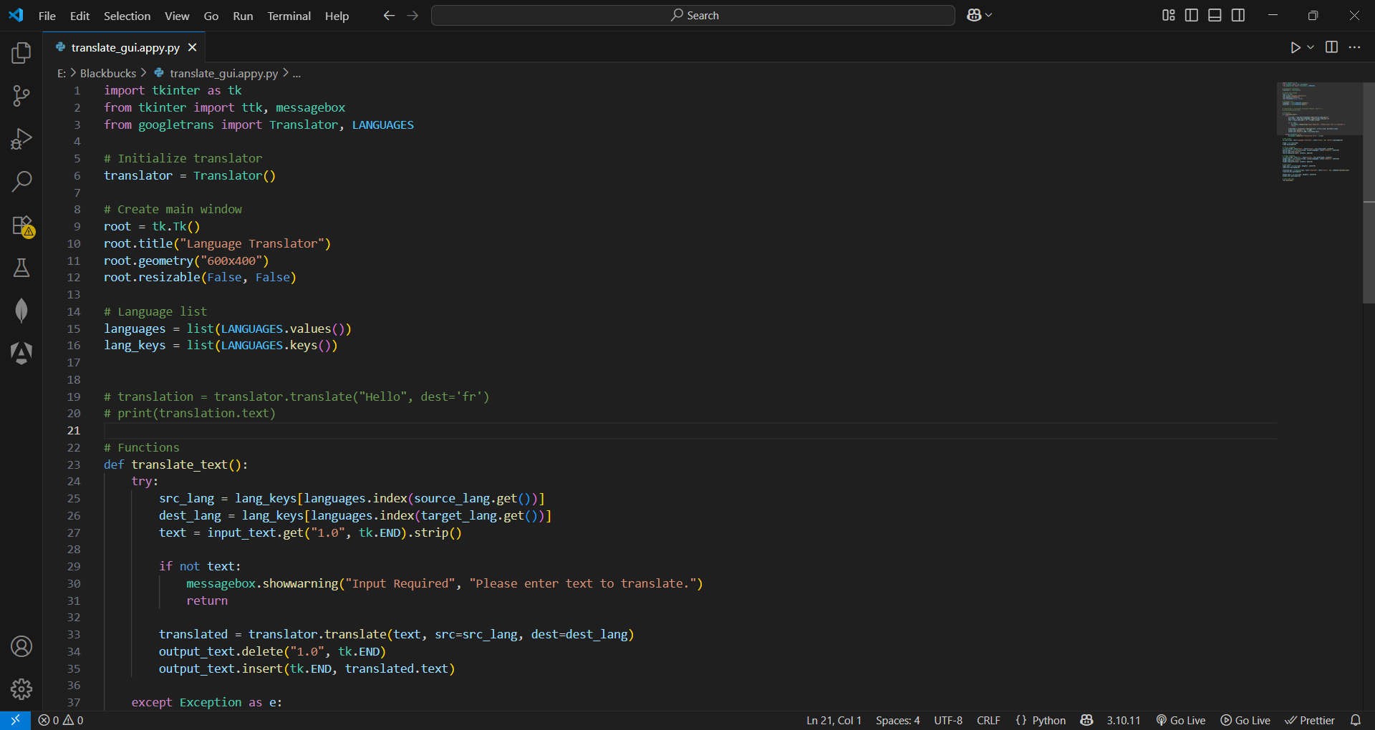

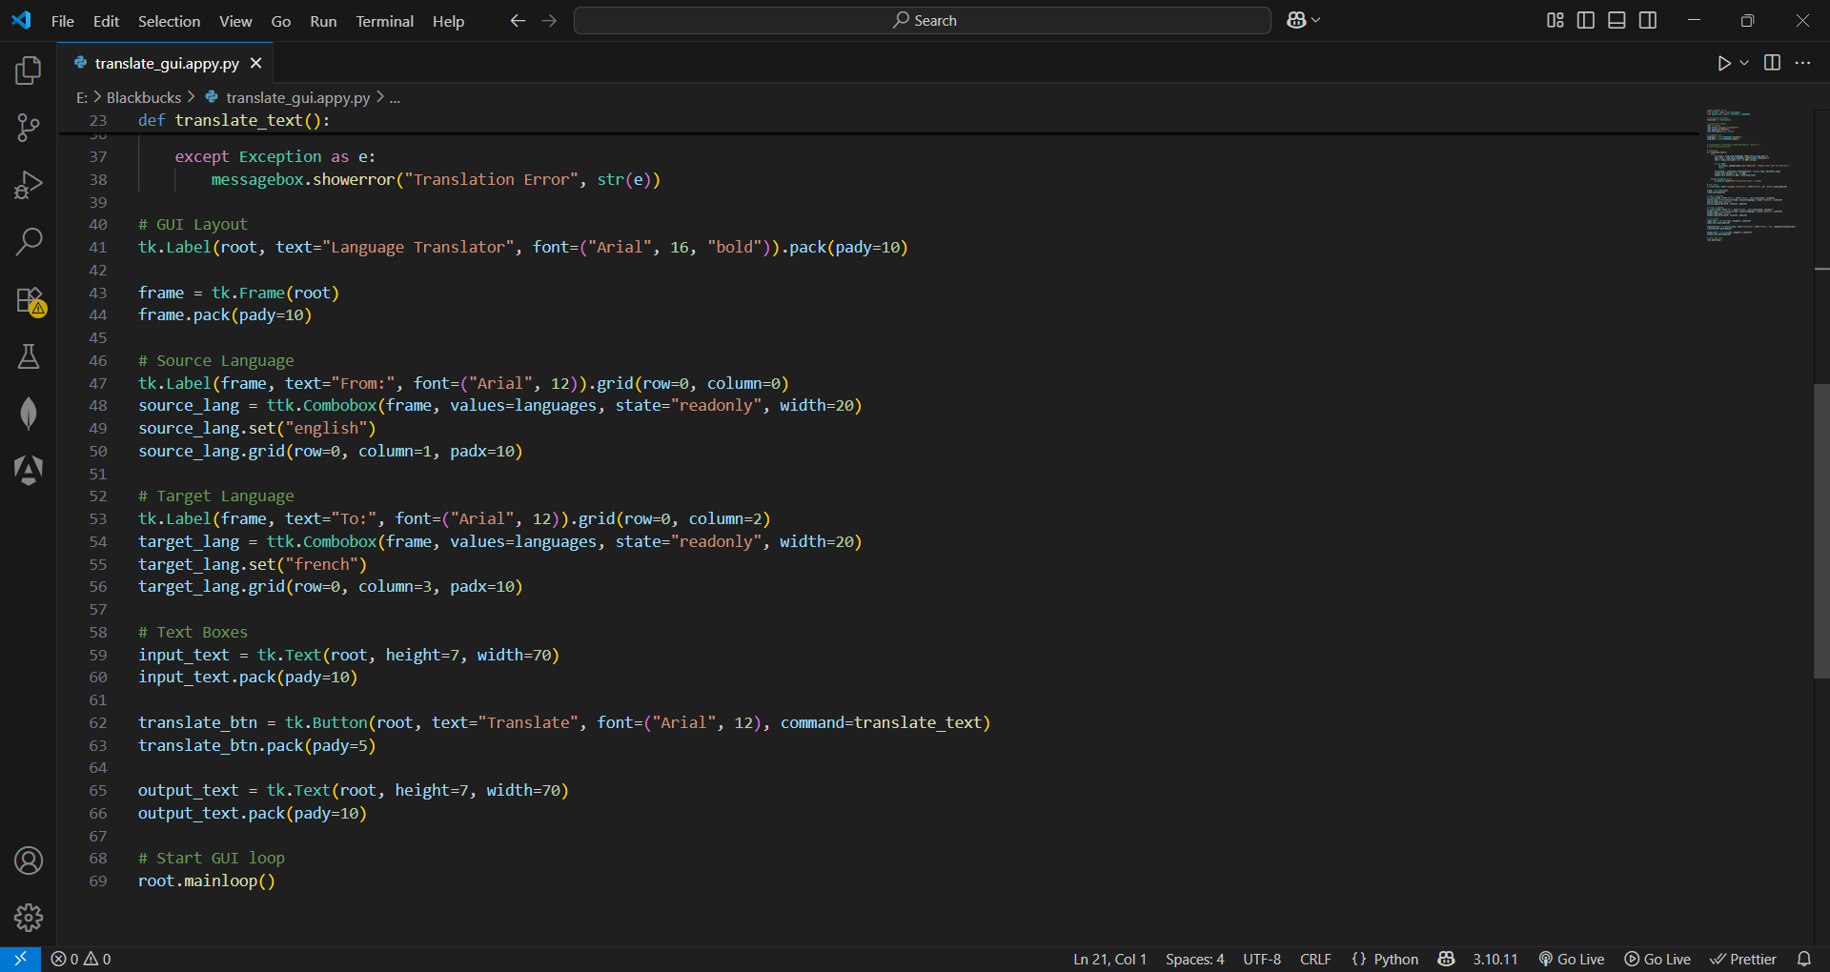

Figure1: Backend (app.py)

**Results and Screenshots**

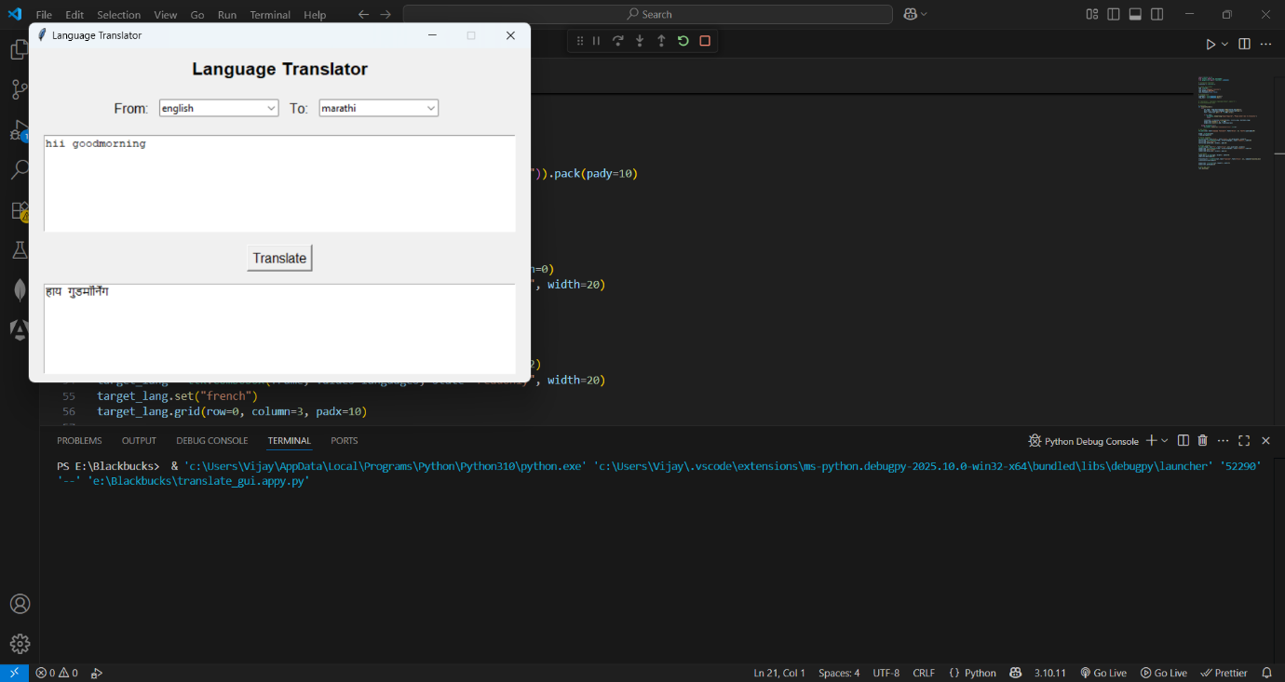

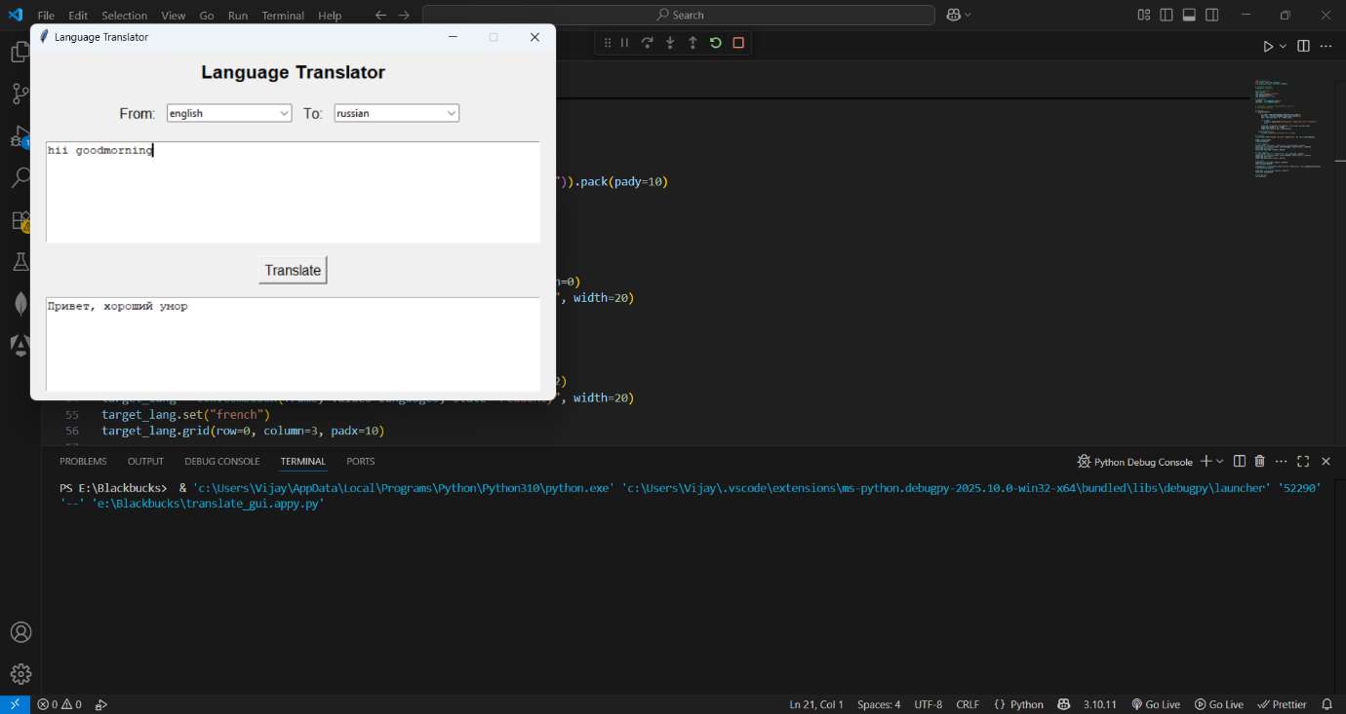

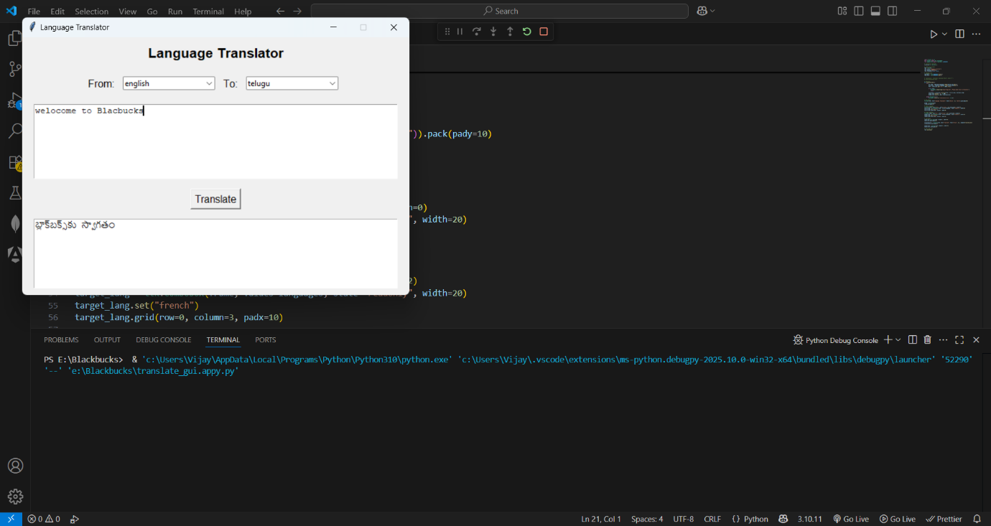

**Testing and Validation**

Testing and validation were performed to ensure that the Language Translator using ChatGPT project works reliably across different input scenarios. Various test cases were designed to check the correctness of translations, the responsiveness of the system, and the handling of edge cases like empty inputs or unsupported languages. The system passed all functional tests, providing accurate translations and a seamless user experience.

**Test Cases**

| **Test Case** | **Description** | **Expected Result** | **Status** |
| --- | --- | --- | --- |
| TC1 | Translate English text to French | Correct French translation is displayed | Passed |
| TC2 | Translate English text to Spanish | Correct Spanish translation is displayed | Passed |
| TC3 | Translate empty input | Displays an error or no translation | Passed |
| TC4 | Translate a paragraph to Hindi | Full paragraph translated correctly | Passed |
| TC5 | Invalid language selection | Handles gracefully without crash | Passed |
| TC6 | Multiple consecutive translations | System remains responsive and accurate | Passed |

**Sample Inputs and Outputs**

| **Input Text** | **Target Language** | **Translated Output** |
| --- | --- | --- |
| Hello, how are you? | French | Bonjour, comment ça va ? |
| Good morning everyone! | Spanish | ¡Buenos días a todos! |
| I love learning languages. | German | Ich liebe es, Sprachen zu lernen. |
| Welcome to my project. | Hindi | मेरे प्रोजेक्ट में आपका स्वागत है। |
| This is a sample sentence. | Telugu | ఇది ఒక నమూనా వాక్యం. |

The above results validate the effectiveness of the translator. The system consistently returns meaningful and context-aware translations. The project is thus fully functional and ready for practical use.

**Advantages of the Project**

The Language Translator using ChatGPT project offers multiple advantages, making it a practical and efficient tool for real-world language translation needs. By integrating artificial intelligence and a simple web interface, this project delivers faster, more accurate, and context-aware translations compared to traditional language translators**.**

**1. Context-Aware Translation**

Unlike many rule-based translators, this system understands the context of the given sentence. It provides more natural, fluent, and human-like translations by considering sentence structure, idioms, and tone, ensuring better communication across languages.

**2. Multi-Language Support**

The project supports translation into multiple languages such as French, Spanish, German, Hindi, Telugu, and others. It can easily be expanded to cover over 100 languages supported by ChatGPT, making it highly scalable.

**3. Simple and User-Friendly Interface**

The project features a clean and easy-to-use interface that allows users to input text and get instant translations without complex steps. This simplicity makes it accessible to users of all technical backgrounds**.**

**4. Fast and Real-Time Response**

With the help of ChatGPT’s API, the project provides translations within seconds. The fast response time ensures that users can translate large texts quickly without delays.

**5. AI-Powered Smartness**

The use of the ChatGPT API allows the system to go beyond basic translation by handling grammatical nuances, cultural expressions, and advanced sentence structures more effectively than traditional dictionary-based translators.

**6. Easy Integration and Extensibility**

The system is designed using Flask, making it lightweight and easy to integrate with other applications or services. Developers can extend the application by adding new languages, improving the frontend, or deploying it on cloud platforms.

**7. Practical Applications**

This project can be used in multiple sectors including education, tourism, customer support, and communication services, thereby making cross-language communication easier and smoother in real-world scenarios**.**

**Limitations of the Project**

Although the Language Translator using ChatGPT project demonstrates high accuracy and user-friendliness, there are certain limitations that need to be acknowledged. Recognizing these limitations is important for understanding the boundaries of the current system and identifying areas for future improvement.

**1. Dependency on Internet Connectivity**

The project relies on real-time interaction with the OpenAI ChatGPT API. This means it requires a stable internet connection to function. In environments with poor internet connectivity, the translation service may be interrupted or unavailable.

**2. API Usage Limits**

The OpenAI API comes with certain usage limits and costs. Free-tier accounts have limited access, and paid tiers incur costs based on the number of API requests. This restricts unlimited usage, especially in large-scale deployments**.**

**3. Occasional Inaccuracies in Translation**

While ChatGPT provides more natural translations, it is not immune to errors. Sometimes, translations may be slightly inaccurate, especially for rare phrases, highly technical terms, or informal expressions**.**

**4. Limited Control over Translation Style**

The project depends on ChatGPT’s internal language model, which may not always allow fine-tuning of translation style (formal vs informal tone) or adherence to specific linguistic preferences unless more advanced prompting techniques are used.

**5. No Voice or Audio Features**

Currently, the system only supports text-based input and output. It does not handle speech-to-text or text-to-speech features, limiting its usage in scenarios requiring voice-based interaction.

**Future Scope**

The Language Translator using ChatGPT project, in its current form, successfully performs basic language translation tasks with the help of artificial intelligence. However, there are numerous possibilities to expand and enhance the project in the future, making it even more useful, efficient, and feature-rich. The following points highlight the future scope of this project:

**1. Expansion to More Languages**

Currently, the system is configured to translate into a limited number of languages. In the future, the project can be easily expanded to support over 100 languages by modifying the user interface and backend logic, making it a truly globaltranslation tool.

**2. Integration of Voice Features**

By integrating text-to-speech (TTS) and speech-to-text (STT) functionalities, users can interact with the translator using voice commands and receive spoken output. This will improve accessibility, especially for visually impaired users or those with limited typing skills.

**3. Mobile Application Development**

The project can be extended to develop a mobile application version for Android and iOS platforms. This will allow users to access the translator on the go, enhancing portability and convenience.

**4. Offline Translation Mode**

A possible improvement is to introduce an offline translation feature using lightweight AI models. This will make the application useful even without internet connectivity, especially in remote areas.

**5. Smarter Context Adaptation**

Advanced prompt engineering techniques or fine-tuning methods can be used to further improve context handling. The system can be adapted to understand formal or informal tones and provide more accurate translations based on the user’s needs.

**6. Real-Time Translation in Chat Applications**

The translator can be integrated with chat platforms like WhatsApp, Slack, or Telegram for real-time language translation during messaging, making multi-language communication easier and smoother.

**7. AI Feedback and Learning System**

By introducing a feedback option where users can rate the translation quality, the system can be further refined. Feedback data can be analyzed to continuously improve prompt design and overall accuracy.

**Conclusion**

The **Language Translator using ChatGPT** project successfully demonstrates the application of advanced natural language processing (NLP) techniques to enable real-time and accurate translation across multiple languages. By leveraging the power of ChatGPT, a state-of-the-art transformer-based language model, this system goes beyond simple word-by-word translation, focusing instead on capturing the context, tone, and intent behind the text.

The integration of ChatGPT ensures that translations are not only linguistically accurate but also semantically meaningful, which is a critical aspect of human-like communication. This project highlights how AI can bridge linguistic barriers and promote more inclusive and effective global communication.

Furthermore, the project’s user-friendly interface, scalability, and support for a wide range of languages make it a practical tool for real-world applications in education, business, travel, and international collaboration.

In summary, the language translator powered by ChatGPT stands as a powerful example of how AI can be harnessed to make communication seamless across cultures and languages, paving the way for more connected and accessible digital experiences.

**References**

1. OpenAI, “ChatGPT API Documentation,” OpenAI Official Website, <https://platform.openai.com/docs>
2. Flask Documentation, “Flask Web Framework,” https://flask.palletsprojects.com
3. W3Schools, “HTML and CSS Tutorial,” <https://www.w3schools.com>
4. Jinja2 Templating Documentation, “Jinja2 Documentation,”
5. https://jinja.palletsprojects.com
6. Brownlee, Jason, “A Gentle Introduction to Natural Language Processing,” Machine Learning Mastery, <https://machinelearningmastery.com>
7. Vaswani et al., “Attention Is All You Need,” Google AI Research Paper, 2017.
8. “Introduction to Language Translation,” GeeksforGeeks Tutorials, <https://www.geeksforgeeks.org>
9. Stack Overflow Community Discussions on Flask and OpenAI Integration, <https://stackoverflow.com>
10. Real Python, “Creating Web Applications with Flask,” https://realpython.com/flask-by-example-part-1-project-setup/

**THANK YOU**